**Microsoft Azure**

**Cloud** **Computing :** Cloud computing is the delivery of computing services like storage, servers, and software over the internet to enable flexible, scalable, and on-demand access.

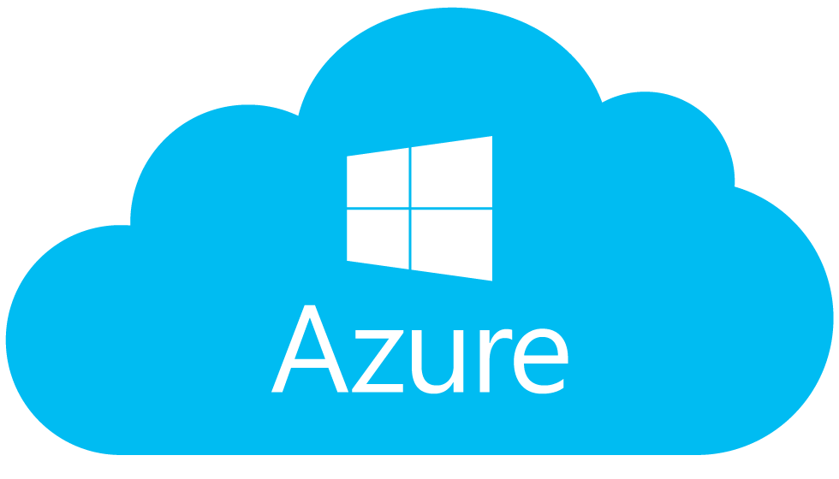

**Azure architectural** **components :**

1. Compute
2. Networking
3. Storage
4. Analytics (Optional).

Types of Cloud :

1. **Public** **Cloud :** Solutions are readily available from azure, Azure provide infrastructure and services in public.
2. **Private** **Cloud :** A private cloud is a cloud computing environment dedicated to a single organization, offering greater control, security, and customization.
3. **Hybrid** **Cloud :** A hybrid cloud combines private and public cloud environments to enable data and application sharing between them for greater flexibility and optimization.

**Azure User** **Account :** Free Azure Accountfrom

<https://azure.microsoft.com/en-us/pricing/purchase-options/azure-account?icid=azurefreeaccount>

==> 1 year Free popular service.

==> $200 Credit for 1 month

==> 25 services

**Scalability** in cloud computing refers to the ability to increase or decrease IT resources as needed to meet changing demand.  
The main types are **vertical scalability** (adding more power to existing machines) and **horizontal scalability** (adding more machines to distribute the load).

**Capital Expenditure (CapEx)** is the upfront investment in physical assets like servers and infrastructure.  
 **Operational Expenditure (OpEx)** involves ongoing costs for services and resources, like cloud subscriptions, paid as needed.